# Homework 2 Answer Sheet

## MongoDB: MovieLens User Ratings Queries

Note: For queries with many results, you may limit the results to a few records. This means, you don't have to show the complete result in your screenshot. You can use the documentation in MongoDB: <https://docs.mongodb.com/manual/>. With the exception of query 9, you should be able to answer all queries with the help of the tutorial in Homework 2 part 1.

Example:

Display the movie information for the movie with the ID 1.

db.movies.find({_id:1 }).pretty();

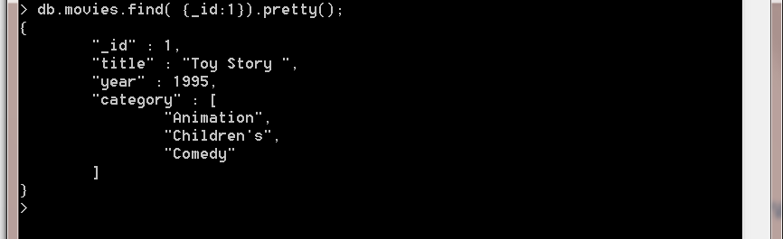

Now it's your turn:

1. Display all occupations. Each occupation should be displayed once.
2. Chose an occupation and select all users with this occupation. Only show user information and hide the users' movie ratings.
3. Count the number of men in the database.
4. Select all users whose zipcode starts with a 5. Only show the user ID and zipcode.
5. Select all movies from the year 1998 and category comedy.
6. Count the number of movies from the year 1990 and 1995.
7. Display all movies published before the year 1992.
8. Imagine that you registered for MovieLens. Create a new user with your user data. Do not include any ratings.
9. Update the user record you created in the previous query and insert a new rating for a movie of your choice. You will need to use $addToSet (<https://docs.mongodb.com/v3.0/reference/operator/update/addToSet/>) to add a value that does not exist in an array to the end of the array. You can use Math.round(new Date().getTime()/1000) to calculate the time in Unix format (seconds since start from epoch).
10. A query of your choice.

## Redis

Please describe your solution. Do not forget to include screenshots of the commands in Redis.